

[Artificia](https://doi.org/10.1016/j.ailsci.2021.100014)l[IntelligenceintheLifeSciences1(2021)100014](https://doi.org/10.1016/j.ailsci.2021.100014)

|  |  |  |
| --- | --- | --- |
|  | Contentslistsavailableat[ScienceDirect](http://www.ScienceDirect.com) |  |
| ArtificialIntelligenceintheLifeSciences |
| journalhomepage:[www.elsevier.com/locate/ailsci](http://www.elsevier.com/locate/ailsci) |

ResearchArticle   
Maxsmi:Maximizingmolecularpropertypredictionperformancewith confidenceestimationusingSMILESaugmentationanddeeplearning TaliaB.Kimbera,∗,MaximeGagnebinb,AndreaVolkamera,∗  
a*InsilicoToxicologyandStructuralBioinformatics,InstituteofPhysiology,Charité-UniversitätsmedizinBerlin,Charitéplatz1,10117,Berlin,Germany* b*Berlin,Germany*

|  |  |  |
| --- | --- | --- |
| article | info | abstract |
| *Keywords:*  Deeplearning  Molecularpropertyprediction Dataaugmentation  Open-source  Confidenceassessment  SMILES | | Accuratemolecularpropertyoractivitypredictionisoneofthemaingoalsincomputer-aideddrugdesign.Quan-titativestructure-activityrelationship(QSAR)modelingandmachinelearning,morerecentlydeeplearning,have becomeanintegralpartofthisprocess.Suchalgorithmsrequirelotsofdatafortrainingwhich,inthecaseof physico-chemicalandbioactivitydatasets,remainsscarce.Toaddressthelackofdata,augmentationtechniques areincreasinglyappliedindeeplearning.Here,weexploitthatonecompoundcanberepresentedbyvarious SMILESstringsasmeansofdataaugmentationandweexploreseveralaugmentationtechniques.Convolutional andrecurrentneuralnetworksaretrainedonfourdatasets,includingexperimentalsolubility,lipophilicity,and bioactivitymeasurements.Moreover,theuncertaintyofthemodelsisassessedbyapplyingaugmentationonthe testset.Ourresultsshowthatdataaugmentationimprovestheaccuracyindependentlyofthedeeplearning modelandofthesizeofthedata.ThebeststrategiesleadtotheMaxsmimodels,themodelsthat**max**imizethe performancein**SMI**LESaugmentation.OurfindingsshowthatthestandarddeviationoftheperSMILESpre-dictioncorrelateswiththeaccuracyoftheassociatedcompoundprediction.Inaddition,oursystematictesting ofdifferentaugmentationstrategiesprovidesanextensiveguidelinetoSMILESaugmentation.Apredictiontool usingtheMaxsmimodelsfornovelcompoundsontheaforementionedphysico-chemicalandbioactivitytasksis madeavailableat<https://github.com/volkamerlab/maxsmi>. |

**1.Introduction**

Drugdesignisatime-consumingandcostlyprocess[1,2]withhigh attritionrates[3].Itcanbesupportedwith*insilico*methodsbyguiding thedesignprocess,optimizingcompounds,anddiscardingthosewith undesiredpropertiesatanearlystageofdevelopment.Inthiscontext, computer-aideddrugdesign(CADD)hasbecomecentralinthedrug discoverypipelineandiswidelyadoptedinresearchanddevelopment inbothacademiaandpharmaceuticalcompanies.

Overthelastfewdecades,therehasbeenakeeninterestinma-chinelearning(ML)andmorespecificallydeeplearning(DL),which havebeenappliedtoavarietyofareas,coveringcomputervision[4], speechrecognition[5],aswellasthelifesciences.Onlytonameafew, AlphaFold2fromDeepMindwhichpredictsproteinfolding[6],Poten-tialNetwhichfocusesonprotein-ligandbindingaffinity[7],*denovo* moleculardesignsuitableforcompoundoptimization[8],andcytotox-icitypredictionasintheworkbyWebeletal.[9].Suchexcitementin DLmaybeexplainedbythemainthreefollowingfactors[10].

1.Thegainofcomputationalpowerthroughgraphicsprocessing units(GPUs)andtensorprocessingunits(TPUs).Platformssuch asGoogleColaboratory[11]allowanyusertoexploithighperfor-mancecomputingresourceswithoutanycostandsuchfreeandeasy accessisunprecedented.

2.Theevergrowingamountofavailabledata.Moredataarecreated andstoredindatabaseseverydayinvariousfields.Manyprocesses areautomatizedmakingdatamoreaccessibleandusableeitherin- ternally,asinpharmaceuticalcompanies,orpublicly.Forexample inacademicresearch,incompetitions,suchasKaggle[12],orin challenges,suchasD3R– theDrugDesignDataResourcechal- lenge[13]ortheTox21challenge[14].

3.Theadvancesinalgorithms,makingmodelsperformbetterthanever before.Deeplearningalgorithmsmaysurpasshumanperformance iftrainedonadatasetcontainingover10milliondatapoints,as suggestedbyGoodfellowetal.[10].

WiththeriseofML/DLresearch,manyapplicationshavebeenex-tendedtothefieldofmolecularpropertyandaffinityprediction,even thoughinsufficientdataremainsachallengeinthefield.

∗Correspondinga[uthor.](mailto:talia.kimber@gmail.com)

*E-mailaddresses:*[talia.kimber@gmail.com](mailto:talia.kimber@gmail.com)(T.B.Kimber),[andrea.volkamer@charite.de](mailto:andrea.volkamer@charite.de)(A.Volkamer).

<https://doi.org/10.1016/j.ailsci.2021.100014>  
[Received4October2021;Receivedinrevised](https://doi.org/10.1016/j.ailsci.2021.100014)form13November2021;Accepted15November2021   
Availableonline18November2021   
[2667-3185/© 2021TheAuthors.PublishedbyElsevi](http://creativecommons.org/licenses/by-nc-nd/4.0/)erB.V.ThisisanopenaccessarticleundertheCCBY-NC-NDlicense (<http://creativecommons.org/licenses/by-nc-nd/4.0/>)

*T.B.Kimber,M.GagnebinandA.Volkamer*

Encodingmolecularcompoundsinbothhuman-andcomputer-readableformatsisanecessarystepinCADD.Aconvenientencoding isSMILES,orsimplifiedmolecular-inputline-entrysystem[15].Asthe namesuggests,SMILESisalinearnotationofamoleculebasedonatom andbondenumeration,aswellasbranch,ringclosure,anddisconnec-tionspecification.Severaladvantagesarisefromthiscompactrepresen-tation.

1.TheprintablecharactersmakeSMILESeasilyreadablebycomputers anddecipherablebyhumans.

2.Beingasingleline,SMILESresemblewordsandarethereforecheap tostore.

3.Suchanotationisverypopularandmanyopen-sourcedatabases storecompoundsinSMILES.

However,thereisatrade-off betweenreadabilityandspecification: havingacompactencodingmeanslosingdetailedinformationaboutthe moleculesuchas2Dor3Dfeatures.Moreover,subtlechemistryrules suchasaromaticitydonothaveastandardwayofbeinghandled[16]. TheimplementationofaSMILESgivenacompoundcanbedescribed asfollows:fromanystartingatominthemolecule,enumeratetheatoms andbondsfollowingapathinthemoleculargraph.Twoaspectsofthis constructionleadtothenon-uniquenessofSMILES:1.theatomtostart theenumerationfrom,and2.thepathtofollowalongthegraph. Therefore,onemoleculecanhavemanydifferentvalidSMILES,sim-plybystartingtheenumerationfromadifferentatomorbychoosing adifferentpath.Nevertheless,insomesettings,havingabijectionbe-tweenamoleculeanditsSMILESnotationmaybesought.Forexam-ple,whendeterminingtheoverlappingmoleculesfromtwodatasets. Inthiscontext,mostcheminformaticstoolshavetheirownalgorithm implementedallowingthemtoalwaysretrievethesameSMILESgiven amoleculargraph,suchaSMILESiscalledcanonical[17].

Asmentionedpreviously,deeplearningbeingdatagreedyandboth physico-chemicalandbioactivitydatabasesbeingmeager,elaborate techniqueshavetobeintegratedtounleashthefullpotentialofdeep neuralnetworks.Inthiscontext,dataaugmentationingeneral[18,19], andmorespecificallySMILESaugmentation[20–23],isapowerfulas-sistanceinmolecularprediction.Fromamachinelearningperspective, dataaugmentationallowsthemodeltoseethesameobjectthrough differentanglesandhasbeensuccessfullyappliedinimageclassifica-tion[4,24],whereimagesundergotransformationssuchasflipping, coloring,cropping,rotating,andtranslating.Fromacomputationalper-spective,SMILESaugmentationisadvantageousbecausegeneratingran-domSMILESisfastandmemoryefficient,andeventhoughtraining amodelmaybemorecomputationallyexpensive,itremainscheapto evaluate.

ThefirstoccurrenceofSMILESaugmentationinQSARmodeling wasdevelopedbyBjerrum[20],whereaffinityagainstdihydrofolate reductase(DHFR)ispredictedonasmalldatasetof756compounds. Themodelconsistsoflongshort-termmemory(LSTM)layersanda fullyconnectedlayerforthenormalizedlog*𝐼𝐶*50value.Eachmolecule inthedatasetisaugmentedonaverage130times.Themodelwith SMILESaugmentationreachesatestcorrelationcoefficientof0.68,a 0.12increasewithrespecttothecanonicalmodel.Fromthenon,sev-eralstudieshavebuiltonthesameidea,applyingSMILESaugmenta-tioninQSARmodeling[21].Moreover,convolutionalneuralnetworks havesuccessfullybeenappliedinthecontextofSMILESaugmentation, outperformingmodelsusingtraditionalmoleculardescriptors[22,23]. Suchaugmentationtechniqueshavealsoemergedinrelatedfields,such asretrosynthesis[25,26]andgenerativemodeling[27,28].Whileall thesestudiesshowthebenefitofaugmentingthedata,noneofthem focus,tothebestofourknowledge,onasystematicanalysisonhow toaugmentthedatasetbest,andmostdecide*apriori*onanaug-mentationnumber.Thisstudyaimsatfillingthisgapbyofferinga systematicaugmentationapproach,bothintheaugmentationstrate-giesandbyhowmuchthedatashouldbeaugmented.Moreover,a command-lineinterfaceisavailableforusersinterestedinthepredic-

2

*T.B.Kimber,M.GagnebinandA.Volkamer*

function*𝑓*(*𝑚*)whichgrowsslowerthanlinearisusedtocontrolthenum-berofreplicaskeptforeachSMILES.Sensiblefunctionswouldbethe squaredrootfunction*𝑓*(*𝑚*)= theformerbeingusedfortheexperimentsinthisstudy.√*𝑚*orthenaturallogarithm*𝑓*(*𝑚*)=ln(*𝑚*),

Acornercaseoftheformerthreeaugmentationstrategiesbyaug-mentationnumber*𝑚*iswhen*𝑚*=1.Inthisinstance,arandomSMILES willbegeneratedandthenumberofdatapointswouldstillbe*𝑁*,asin the“noaugmentation” case,withthedifferencethat“noaugmentation”containscanonicalSMILESonly.

*2.1.5.Augmentationwithestimatedmaximum*   
 Thefinalstrategydescribedisaugmentationwithestimatedmax-imum,whichaimstocoverawiderangeofthevalidSMILESspace foragivencompound,orinotherwords,togenerateanumberof uniqueSMILESthatdependsonthecompound.Inourstudy,theim-plementationofthisaugmentationstrategyrandomlysamplesSMILES correspondingtoacompound,andthesamplingprocessisstopped oncethesameSMILESstringhasbeengeneratedapre-definednum-beroftimes.Theexperimentsofthisstudyset10generationsof thesameSMILESasastoppingcriterion.Itisnoteworthythatthe numberofSMILESthismethodgeneratesishighlydependentonthe sizeofthecompound,unlikethepreviousmethodswhichalways generateanumberofSMILESboundedby*𝑚*.Forexample,ourim-plementationofthisaugmentationstrategygenerated50659unique SMILESvariationsforthecompoundgivenbythecanonicalSMILES CC(=O)C1(C)CCC2C3C=C(C)C4=CC(=O)CCC4(C)C3CCC21C,whereas onlythreeweregeneratedforthecanonicalSMILESC=CC=C,namely C(=C)C=C,C(C=C)=C,andC=CC=C.

*2.2.SMILESaugmentationasensemblelearningforcompoundprediction andconfidencemeasure*

Theapplicationofdataaugmentationstrategiesduringtraininghas proventobesuccessful,asshowninpreviousworks[4,24].InQSAR modelingparticularly,SMILESaugmentationisnotonlybeneficialon thetrainingset[22],buttherearealsoadvantagesofaugmentingthe testset,ormoregenerally,anunlabeleddataset,asexplainedinthis section.

Letusassumethatamodel*𝑀* withasetofparametersΘ was trainedforacertainnumberofepochs.Letusconsideranunlabeled datasetcontaining*𝑁* compoundsforwhichwewanttomakepre-dictions.Eachcompound*𝐶* canbeaugmentedusingrandomSMILES: *𝑆*1(*𝐶*)*,𝑆*2(*𝐶*)*,*… *,𝑆𝑘*(*𝐶*),where*𝑘*dependsonthestrategy.Themodel*𝑀*Θ producesapredictionforeachofthoseSMILES,i.e.for*𝑖*∈ {1*,*… *,𝑘*}

*̂𝑦𝑖*(*𝐶*)=*𝑀*Θ(*𝑆𝑖*(*𝐶*))*,*

leadingtoa*perSMILES*predictionratherthana*percompound*predic-tion.Usinganaggregationfunction*𝐴*∶ℝ*𝑘*→ ℝ,suchasthemean,a predictionforcompound*𝐶* canbecomputedas

*̂𝑦*(*𝐶*)=*𝐴*(*̂𝑦*1(*𝐶*)*,*… *,̂𝑦𝑘*(*𝐶*))*.* SuchaggregationcanbeviewedasaconsensusamongtheSMILESpre-dictionandinterpretedasensemblelearningforagivencompound. Additionally,ifthestandarddeviationsofthepredictionsarecom-puted,theycanbeinterpretedasaconfidenceinthemolecularproperty oractivityprediction.Ifthestandarddeviationislarge,thenthereisa highvariationintheperSMILESprediction,andthemodelisuncertain initspercompoundprediction.Anillustrationofsuchamolecularpre-dictionisshowninFig.1.FollowingtherationalebyTagasovskaand Lopez-Paz[31],thealeatoricandepistemicuncertaintiesareoftenin-tertwined;theuncertaintycomputedinourworkratherfallsintothe aleatoriccategory,atypeofuncertaintylinkedtothemodelpredictions andtherandomnessintheinputdata[31–33].

3

*T.B.Kimber,M.GagnebinandA.Volkamer*  *ArtificialIntelligenceintheLifeSciences1(2021)100014*

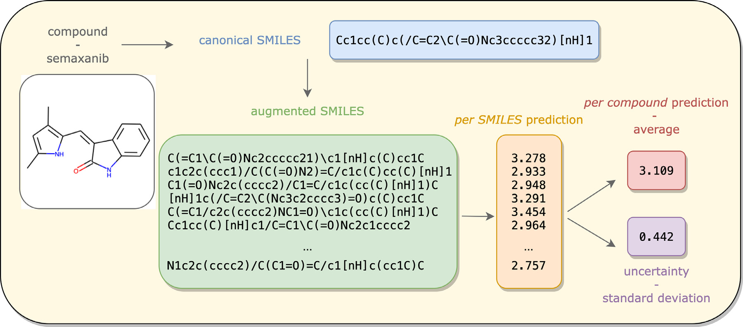

**Fig.1.CompoundpredictionandconfidencemeasurethankstoSMILESaugmentation.**GivenacompoundrepresentedbyitscanonicalSMILES,asetof randomSMILESaregenerated.ThetrainedmachinelearningmodelproducesapredictionforeachoftheSMILESvariations.Aggregatingthesevaluesleadstoaper compoundpredictionandcomputingthestandarddeviationisinterpretedasanuncertaintyintheprediction.

**Table1**   
**Datasetsforthisstudy.**Sizeofthedatasetsbeforeandafterpreprocessing,aswellasthesizeofthetrainingandtestsetsbeforeapplyinganaugmentation strategy,andtheprovenanceofthedata.

|  |  |  |  |  |  |
| --- | --- | --- | --- | --- | --- |
| Dataset | Sizebeforepreprocessing | Sizeafterpreprocessing | Trainset80%,beforeaugmention | Testset20%,beforeaugmention | Provenance |
| ESOL  ESOL_small  FreeSolv  Lipophilicity  Affinity(EGFR) | 1128  1128  642  4200  6026 | 1128  1068  642  4199  5849 | 902  854  513  3359  4679 | 226  214  129  840  1170 | MoleculeNeta MoleculeNeta MoleculeNeta MoleculeNeta Kinodatab |

a<https://deepchem.readthedocs.io/en/latest>.   
b[https://github.com/openkinome/kinodata.](https://deepchem.readthedocs.io/en/latest)

morethan14000targetsandtwomillioncompounds[41].Amongtar-gets,kinasesareawellstudiedproteinfamilyduetotheirinvolve-ment,amongothers,incancerandinflammatorydiseases[42].Kin-odata,fromtheOpenkinomeorganization[43],providesanalready curateddatasetofhumankinasebioactivities,retrievedfromoneof thelatestversionstodateofChEMBL(version28)andisfreelyavail-ableat<https://github.com/openkinome/kinodata>.Moreover,forthis study,K[inodataisfurtherfiltere](https://github.com/openkinome/kinodata)d[fortheepiderm](https://github.com/openkinome/kinodata)algrowthfactorre-ceptor(EGFR)kinase[44],sinceitisknowntobeanimportantdrug target.ItsUniProtidentifierisgivenbyP00533[45].Affinitytowards theEGFRkinaseisquantifiedusing*𝑝𝐼𝐶*50values,thenegativebase10 logarithmof*𝐼𝐶*50[46].Informationaboutthedatasetprovenanceand sizearedetailedinTable1.

*3.2.Datapreprocessingandinputfeaturization*

Inordertotrainadeeplearningneuralnetworkondatacontaining molecularcompounds,thedatasetundergoespreprocessingandcom-poundsencoding.

Oncethedatasetsareretrievedfromtheiroriginalsource,invalid SMILES,detectedbyRDKit[29],notavailable(NA)valuesanddis-connectedcompounds,markedbyadotinaSMILES,areremoved. MoleculesaretransformedtothecanonicalSMILESrepresentation,us-ingRDKitfunctionalities.

Formodeltraining,theSMILESareone-hotencoded,basedona dictionaryofuniquesymbolsconstructedfromtheSMILESinthedata. Atomsrepresentedbytwoletters,suchasBrforbromineorClforchlo-rine,aswellas@@forchiralityspecification,aretreatedasifsingle

4

*T.B.Kimber,M.GagnebinandA.Volkamer*

beabletoone-hotencode.Moreover,ifthelengthofthelongestSMILES istakenfromthetrainingsetandnottheunionofthetrainingandtest sets,augmentationonthetestsetcouldproducealongerSMILESthan thelongestoneinthetrainingset,leadingtodimensionalityerrors. Foralltheabovereasons,itisimportantformachinelearningengi-neerstoabidebythestepsasdescribedinthissectionforstatistically correctresults,aswellasprogrammaticerror-freemodeltrainingand evaluation.

*3.4.Experimentalsetupandmodelevaluation*

Inordertodrawaconclusionontheefficiencyofdataaugmentation, threedatasetsofvaryingsizesareconsidered,namelyESOL,FreeSolv, andlipophilicity(seetheProvenancesection).Foreachofthesesets,the dataaresplitonceinto80%trainingand20%testset,withafixedran-domseedfortestingtobeconsistentwiththeaugmentationschemes. Givenallpossiblecombinationsbetweenthefiveaugmentationstrate-giesanddifferentaugmentationnumbers,thethreedeeplearningmod-els,andthevariousdatasets,includingcross-validationwouldhave addedconsiderablecomputationalcostsandhasthereforenotbeenim-plementedinthisstudy.

Formodelevaluation,therootmeansquarederror(RMSE)[48]on thetestsetisreported,sothatthelowertheRMSEvalue,thebetterthe model.Howeveradditionalinformationsuchasthemeasureofgoodness offit,alsoknownastheR2value[49],onbothtrainingandtestsets, aswellasthetimerequiredformodeltrainingandevaluationarealso stored.

Fiveaugmentationsstrategiesarestudied:Noaugmentation,which considersthecanonicalSMILESrepresentation.Theaugmentations with,without,andwithreducedduplication,fornumerousaugmen-tationnumbers:afinergridfrom1to20withastepsizeof1,anda coarsergridfrom20to100withastepsizeof10.Finally,theestimated maximumstrategywhereaSMILESrepresentationhastobegenerated 10timesfortheprocesstostop.Forthislaststrategy,theESOL_small dataset(seeTable1)isusedtokeeptheaugmentationtoareasonable time-scale.Forthesamereason,thesameaugmentationstrategyisnot runonthelipophilicitydataset.

Theaugmentationstrategiesareappliedtoboththetrainingsetand thetestset,sothatforexample,iftheFreeSolvtrainingdatasetisaug-mented20timeswithoutduplication,thensowouldtheFreeSolvtest set.

Ensemblelearningisappliedoneachtestsetandthemeanisusedas aggregation.However,ausercouldeasilyadaptittoanotherfunction, suchasthemedian.Thestandarddeviationisstoredforeachcompound inthetestset.

Moreover,aRandomForest(RF)model[50]isusedasabaseline, withalldefaultparametersfromScikit-learn[51].Theinputstothe modelaretheMorganfingerprintsofradius2andlength1024.Aug-mentationstrategiesasdiscussedabovearenotapplicableinthecontext offingerprints.

SimulationsarerunonaGeForceGTX1080Ti,providedbythecen-tralHPCclusteroftheFreieUniversitätBerlin[52].

*3.5.Codeanddocumentation*

[AllcodeiswritteninPython3[53]followingPEP8style guide[54]andisfreelyavailableathttps://github.com/volkamerlab/ maxsmi.Resultsofthisstudycanbefoundatthesamelink.Examples anddocumentation,generatedviaReadtheDocs[55],canbefoundat](https://github.com/volkamerlab/maxsmi) <https://maxsmi.readthedocs.io/en/latest/>.

[PackagemanagementisdonewithA](https://maxsmi.readthedocs.io/en/latest/)naconda[56].RDKit[29]is usedforcheminformatics,PyTorch[57]fordeeplearning,andother popularpackagessuchasScikit-learn[51],NumPy[58],andPan-das[59]forgeneralpurposes.Continuousintegrationisdeployedwith Githubactions[60]ensuringrunsonLinux,Mac,andWindowsoperat-

5

*T.B.Kimber,M.GagnebinandA.Volkamer*  *ArtificialIntelligenceintheLifeSciences1(2021)100014*

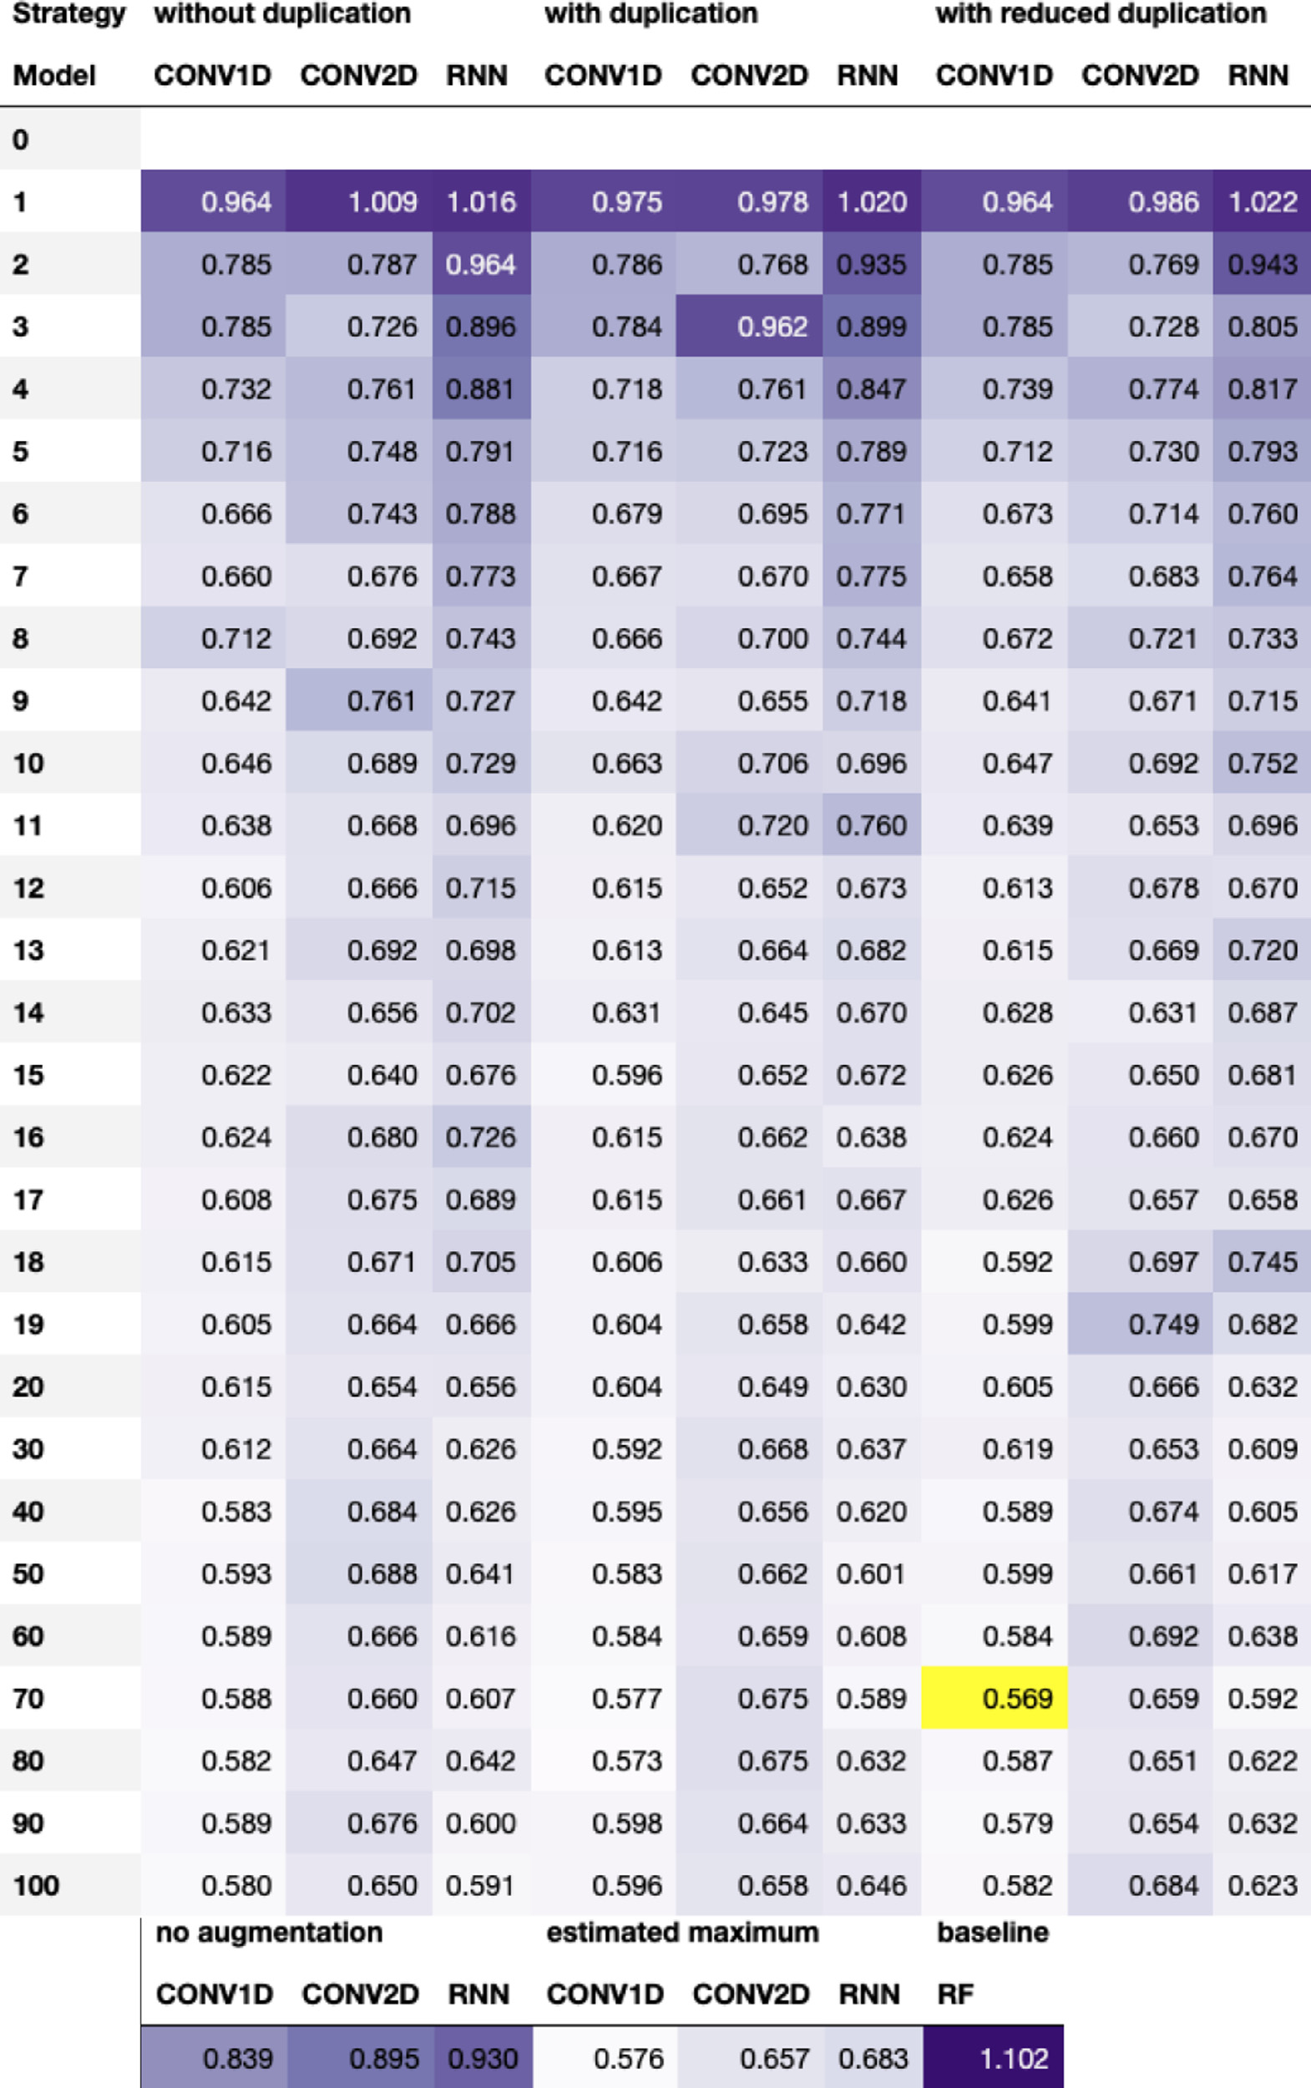

**Fig.2.TestRMSEusingdataaugmentationontheESOLdataset.**Thetableshowstherootmeansquarederror(RMSE)onthetestsetforthreedeeplearning modelsandfiveSMILESaugmentationstrategies,usingvariousaugmentationnumbers,aswellasabaselineconsistingofaRandomForest(RF)modelwithMorgan fingerprintasinput.Thelighterthepurplecolor,thebetterthemodel.Theoverallbestsettingishighlightedinyellow,whichfortheESOLdatasetisaugmenting thedataset70timesusingareducednumberofduplicatesandtraininga1Dconvolutionalneuralnetwork(CONV1D).Forinterpretationofthereferencestocolor inthisfigurelegend,thereaderisreferredtothewebversionofthisarticle.

6

*T.B.Kimber,M.GagnebinandA.Volkamer*

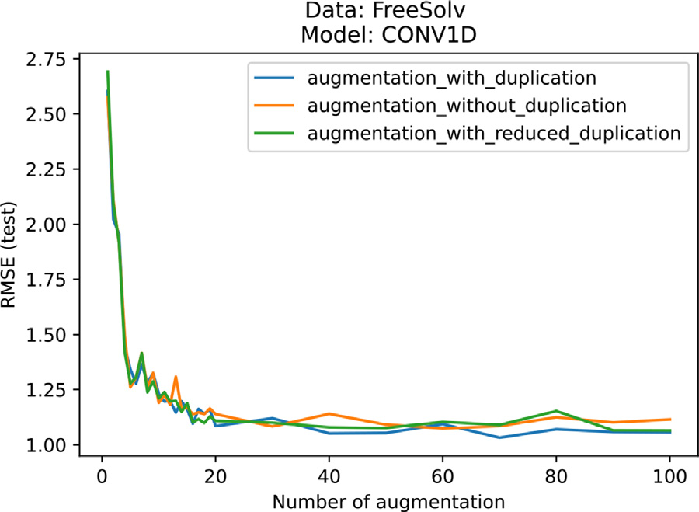

**Fig.3.Performancereachesaplateauindependentlyoftheaugmentation strategy.**TheperformanceoftheCONV1Dmodeltrainedandevaluatedon theFreeSolvdatasetreachesatestRMSEvalueslightlyabove1asof20aug-mentationstepsandfluctuatesaroundthisvaluethereafter,forallaugmenta-tionstrategies:with,without,andwithreducedduplication.FortheESOLand lipophilicitydata,seeFigs.A4andA5.

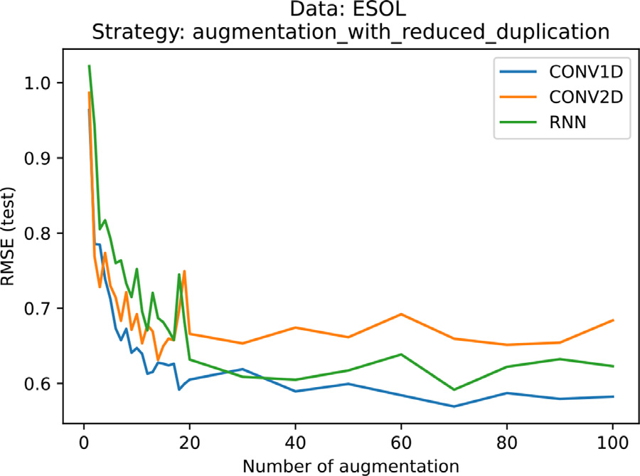

**Fig.4.The1Dconvolutional(CONV1D)modeloutperformstherecur-rent(RNN)and2Dconvolution(CONV2D)models.**Thefigureshowsthe evolutionoftherootmeansquarederror(RMSE)onthetestsetwithrespect tothenumberofaugmentationusingreducedduplicationontheESOLdata. CONV1DoutperformsRNN,whichoutperformsCONV2D.

andtheirabilitytoextractrelevantfeaturesincompoundsbasedonone-hotencodedSMILESinput.Thisalsoimpliesthatalthoughapplying2D convolutionstoSMILESisprogrammaticallyfeasible,1Dconvolutions arebettersuitedthan2Dconvolutions,thelatterhavingshowngreat successinimageclassification.Indeed,whenconsideringtheone-hot encodedmatrix,SMILESaremoresimilartowords,inwhichtheposi-tionoftheatomsisimportant,ratherthantoimages.

*4.1.2.Thereisno*best*augmentationstrategyapplyingtoalldatasets*  Fromanaugmentationstrategypointofview,conclusionsarenot straightforward.Thethreeaugmentationstrategies,namelywith,with-out,andwithreducedduplication,allperformsimilarlywell,without onestandingout.Forexample,thetestRMSEontheFreeSolvdataset trainedusingtheCONV1Dmodelreachesvaluesjustabove1forall threestrategies,asshowninFig.3.

Moreover,generatingalargeportionoftheSMILESspaceusingthe strategywithestimatedmaximumsurprisinglydoesnotleadtothebest results.OntheESOLdataset,thisstrategyreachesatestRMSEof0.683 usingRNN,whereasthesamemodelbutusingstrategieswith,without, andwithreducedduplicationalreadyoutperformstheestimatedmax-imumasofanaugmentationnumberof19andonward,asshownin

7

*T.B.Kimber,M.GagnebinandA.Volkamer*  *ArtificialIntelligenceintheLifeSciences1(2021)100014*

**Table2**   
**The**b**estaugmentationstrategiesdefinetheMaxsmimodels.**Aftertrainingthreedatasets(ESOL,FreeSolv,andlipophilic-ity)onvariousdeeplearningmodels(CONV1D,CONV2D,andRNN),usingdifferentaugmentationnumbersandstrategies, thesettingthatyieldsthebestperformance,orlowestrootmeansquarederror(RMSE)onthetestsetisselectedandnamed theMaxsmimodel.

|  |  |  |  |  |
| --- | --- | --- | --- | --- |
| Data | Model | Augmentationnumber | Augmentationstrategy | TestRMSE |
| ESOL  FreeSolv  Lipophilicity | CONV1D  CONV1D  CONV1D | 70  70  80 | Withreducedduplication Withduplication  Withoutduplication | 0.569  1.032  0.593 |

**Table3**   
**ModelsbasedonthecanonicalSMILESoutperformtheonesbasedonasinglerandomSMILES.**Thetestpredictionfora modeltrainedandevaluatedontheRDKitcanonicalSMILESsystematicallyperformsbetterthanthesamemodeltrainedand evaluatedonasinglerandomSMILES.ESOListhepredictiontaskleadingtothevaluesinthetable.

|  |  |  |  |  |
| --- | --- | --- | --- | --- |
| CanonicalSMILES | RandomSMILES | Truevalue | CanonicalSMILESprediction(&error) | RandomSMILESprediction(&error) |
| CCCCCC  CCCC(=O)CC  CCCC(=O)OCC | C(C)CCCC  C(=O)(CCC)CC C(OC(CCC)=O)C | −3*.*84 −0*.*83 −1*.*36 | −2*.*87(0.97) −1*.*37(0.54) −1*.*14(0.22) | −2*.*77(1.07) −1*.*65(0.82) −0*.*55(0.81) |

recommendedtoconsiderthecanonicalSMILESrepresentationrather thanarandomone.

*4.2.Ensemblelearningforcompoundpredictionandconfidencemeasure*

UsingtheMaxsmimodelsestablishedabove,welookintomorede-tailsattheinformationgainedfromensemblelearningformolecular prediction,andmorespecificallyattheaverageandstandarddeviation computedfromtheperSMILESprediction.FeedingdifferentSMILES representationstothemodelandaggregatingthepredictionforeach SMILESvariationtoobtainasinglepredictionpercompoundisvalu-ablenotonlyfromapracticalpointofviewwheremolecularprediction ismoreinformativethanaSMILESprediction,butitalsoallowsthe modeltomergeinformationcomingfromdifferentperspectivesofthe samecompound.Moreover,thestandarddeviationassociatedwiththe SMILESpredictionsallowstoquantifytheuncertaintyoftheprediction ofthemodeltowardagivencompound.Thehigherthestandarddevia-tionforamolecule,thelessconcurrentarethepredictionsbythemodel, andthus,lessconfident.

*4.2.1.Differencebetweencanonicalvs.averagedprediction*   
 ConsideringtheMaxsmimodelstrainedwiththeirrespectiveaug-mentations,weanalyzethedifferenceinpredictiononthetestsetwhen usingthecanonicalortheaveragedprediction.Morespecifically,we comparethepredictionerroroftheMaxsmimodelswhenevaluatedon thetestsettwice:onceusingthecanonicalSMILESforcompoundpre-dictionandasecondtimeaveragingtheperSMILESpredictionusing thesameaugmentationnumberandstrategywhichwasusedfortrain-ing.Forbothevaluations,theerrorbetweenthepredictionandthetrue valueiscomputed.Fig.6showsthehistogramoftheseerrorsonthe ESOLdata.Asshowninthefigure,morecompoundshaveanerrorclose tozerousingtheensemblelearningevaluationratherthanthecanon-ical,whichincentivestheuseofensemblelearningforfuturestudies. However,thisgainismarginalandthecanonicalpredictionperforms similarlywellcomparedtotheaveragedprediction.Inlightoftheover-allgainintheaccuracyofthemodels,thisindicatesthataugmentation duringtrainingisthemorecrucialstep.Asdiscussedinthefollowing paragraph,anadvantageofusingaugmentationonthetestsetistoes-timatetheconfidenceofthemodelinitsprediction.

*4.2.2.Moreconfidentmodelimpliessmallerpredictionerror*   
 AsmentionedintheSMILESaugmentationasensemblelearningfor compoundpredictionandconfidencemeasuresection,computingthe standarddeviationoftheperSMILESpredictionprovidesaconfidence measureinthecompoundprediction.Inthissection,weanalyzethe

8

*T.B.Kimber,M.GagnebinandA.Volkamer*  *ArtificialIntelligenceintheLifeSciences1(2021)100014*

**Table4**   
**TheMaxsmimodelsreachstate-of-the-artresults.**Comparisonoffourstudiesonthesamedatasets(ESOL,FreeSolv,and lipophilicity).TheMaxsmimodeloutperformsmostoftheothermodelswithalowerRMSEonarandomlysplittestset.

|  |  |  |  |  |  |  |  |
| --- | --- | --- | --- | --- | --- | --- | --- |
| Study | TestRMSE(±stdifavailable) | |  | Split |  |  | Model |
|  | ESOL | FreeSolv | Lipophilicity | Fold | Ratio%(train:valid:test) | Type |  |
| Maxsmi  MoleculeNet[34] CNF[22]  MolPMoFiT[21] | **0.569**  0*.*58±0*.*03 0.62  NA | **1.032**  1*.*15±0*.*12  1.11  1*.*197±0*.*127 | 0.593  0*.*655±0*.*036  0.67  **0.565**±**0.037** | Single  3  5-foldCV 10 | 80∶0∶20 | Random Random Random Random | CNN  GNN  CNN  RNN |
| 80∶10∶10  NA  80∶10∶10 |

Abbreviations:RMSE=rootmeansquarederror,std=standarddeviation,CNN=ConvolutionalNeuralNetwork,GNN= GraphNeuralNetwork,RNN=RecurrentNeuralNetwork,NA=notavailable,CV=cross-validation.

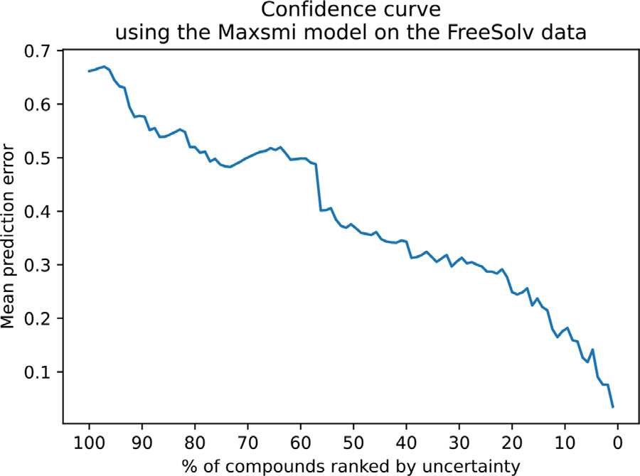

**Fig.7.MoreconfidentMaxsmimodelonFreeSolvimpliessmallerpredic-tionerror.**Thegeneraltrendoftheconfidencecurveisdecreasing,showingthat ascompoundswithhighuncertaintyareremoved,theerrorbecomessmaller.

ThefirstconsideredstudyisMoleculeNet,whereseveralmolecular encodingsandmodelsaretrainedandevaluated,butwherenoaugmen-tationisused.InMoleculeNet,thedataisrandomlysplitintotraining, validation,andtestset,usingan80∶10∶10ratioandrunthreetimes ondifferentseeds.Thebestperformingmodelonthetestsetforboth ESOLandFreeSolvisamessagepassingneuralnetworkwithanRMSE andstandarddeviationof0*.*58±0*.*03and1*.*15±0*.*12,respectively[34, TableS5].Onthelipophilicitydataset,aslightlydifferentgraphmodel performsbestwith0*.*655±0*.*036.Onallthreetasks,theMaxsmiresults performbetterthanMoleculeNet(seeTable4),suggestingthatSMILES augmentationwithshallowneuralnetworkscouldperformatleastas wellas,ifnotbetterthan,graphneuralnetworks(GNNs).

ThesecondstudyweconsideristheConvolutionalNeuralFinger-print(CNF)model[22,23],inwhichSMILESaugmentationisapplied, generatinguniquerepresentationsforeachcompound,i.e.augmenta-tionwithoutduplication.TheCNFmodelisevaluatedusingfive-fold cross-validation(CV),howeverstandarddeviationsarenotreported. TestRMSEvaluesare0.62,1.11and0.66ontheESOL,FreeSolv,and lipophilicitydataset,respectively,see[22,TableS1].SimilartoMolecu-leNet,theMaxsmimodelslightlyoutperformstheseresultsonallthree tasks.Thissuggeststhataugmentingthedatasetbygreaterfactors,e.g.

closerto70asinMaxsmi,yieldsbetterresultsthan10timesaugmen-tationasinCNF.

Finally,theMolecularPredictionModelFine-Tuning(MolP-MoFiT)[21]studybuildsanRNNmodelbasedonLSTMlayersus-ingSMILESaugmentationwithduplication.Thelipophilicitydatais augmented25timeswhereastheFreeSolvdata50times.MolPMoFiT istrainedandevaluatedusing10splitsofratio80∶10∶10forthe training,validation,andtestsets.ThemodelreachesanRMSEvalue (andstandarddeviation)of1*.*197±0*.*127ontheFreeSolvdataand 0*.*565±0*.*037onthelipophilicitydata,see[21,Figure3,4].While MaxsmileadsontheFreeSolvpredictionproblem,MolPMoFiTslightly outperformsMaxsmionthelipophilicitydata(Table4).

Lastly,studycomparisonshouldbetreatedwithutmostattention, sinceresultscannotbecomparedblindly.Forinstance,ifthedatapre-processingisdonedifferentlyineachstudy,orthesplitsarenotiden-tical,ortheparametersoftheexperimentsarenotsettobethesame, thentheresultsarenotfairlycomparable.

*4.4.Testcase:EGFRaffinitydatafollowingtheguideline*

GiventheresultsoftheMaxsmimodelsonthephysico-chemicaldata sets,wenowdiscussguidelinestoapplySMILESaugmentationonanew dataset.TheEGFRaffinitydata,discussedintheProvenancesectionand henceforthsimplyreferredtoasaffinitydata,isusedasatestcase,but theideacanbeappliedtodifferentdatasetsandbroaderusecases. Sincetheaffinitydatasetcontains5849datapointsafterprepro-cessing(seeTable1),thelipophilicityandaffinitydataareofasimilar orderofmagnitude,althoughthelatterissomewhatlarger.Therefore,a compromisebetweenthesizeofthedatasetandthetuplethatgivesthe bestresultsfortheFreeSolv,ESOL,andlipophilicitydata(seeTable2) isfound:fortheaffinitydata,theCONV1Dmodelischosen(similarly tolipophilicity,ESOL,andFreeSolv),thenumberofaugmentationisset to70,asforESOLandFreeSolv,andtheaugmentationstrategyissetto augmentationwithreducedduplicationforalesscomputationalinten-sivetrainingthanaugmentationwithduplication.Ascomparison,the Maxsmi,thecanonical,andthebaselinemodelsonaffinityaretrained andevaluated.Thesameexperimentalsetupforsplittingandevaluation asmentionedintheDataandexperimentalsetupsectionisapplied.On thetestset,thecanonicalmodelreachesanRMSEvalueandcoefficient ofcorrelation*𝑅*2valueof1.031and0.494,respectively.Incompari-son,theMaxsmimodelshowsgreatimprovementwithtestRMSEand *𝑅*2valuesof0.777and0.712,respectively(seeTable5).Surprisingly,

**Table5**   
**TheMaxsmimodelsstrikeagain!**TheMaxsmimodeldevelopedfortheaffinityagainsttheEGFRkinaseandtheRandom Forest(RF)baselinemodeloutperformthecanonicalmodel.

|  |  |  |  |  |  |
| --- | --- | --- | --- | --- | --- |
| Name | Model | Augmentationnumber | Augmentationstrategy | TestRMSE | Test*𝑅*2 |
| Maxsmi  Canonical Baseline | CONV1D CONV1D RF | 70  0  0 | Augmentationwithreducedduplication Noaugmentation  Noaugmentation | 0.777  1.031  0.758 | 0.712  0.494  0.726 |

9

*T.B.Kimber,M.GagnebinandA.Volkamer*

theRFbaselinemodelperformssimilarlytotheMaxsmimodel,withan RMSEof0.758andan*𝑅*2of0.726.

*4.5.Maxsmimodelsavailableforuserpredictions*

GiventhegoodperformanceoftheMaxsmimodelsforallthree physico-chemicaltasksandforEGFRaffinity,weretrainedthemonall pointsinthedatasetasafinalproduct.Theaimistoofferasingle command-lineinterfaceforprediction.AusercanprovideaSMILESas input,chooseagiventaskandtheywillreceiveanoutputfileinthe formofaCSVtablewithrelevantinformation,suchas1.theuserinput SMILESitself,2.whetherthecompoundwasinthetrainingset,3.the canonicalSMILES,anditsassociatedvariations4.theperSMILESpre-dictions,5.thepercompoundprediction,6.andthestandarddeviation. APNGfileofthe2Dmoleculargraphassociatedwiththein-putSMILESisalsogenerated.Forexample,forthesemaxanibdrug, takenfromthePKIDBdatabase[63],andgivenbytheSMILES O=C2C(\1ccccc1N2)=C/c3c(cc([nH]3)C)C,lipophilicityis predictedusingthecommand-line   
 $pythonmaxsmi/prediction_unlabeled_data.py--task=”lipophilicity” --smiles_prediction=”O= C2C(\1ccccc1N2)=C/c3c(cc([nH]3)C)C”  
 ThecommandabovewasusedtogeneratethevaluesinFig.1.

**5.Conclusion**

Inthisstudy,SMILESaugmentationappliedtodeeplearningmolec-ularpropertyandactivitypredictionisinvestigated.Fiveaugmentation strategiesthatcanbeappliedasSMILESaugmentationareexplored, togetherwiththreeneuralnetworkarchitectures,andtheperformance thoroughlyassessedonthreemoleculardatasets:ESOL,FreeSolv,and lipophilicity.

Ourfindingsshowthataugmentationimprovestheperformanceof deeplearningmodelsnotonlyindependentlyofthemodel,butalso withrespecttothesizeofthedataset.Thissuggeststhatthechoiceof augmentationstrategycanbeviewedashyper-parametertuning. Thetupleconsistingof(model,augmentationnumber,augmenta-tionstrategy)thatmaximizestheperformanceonthetestsetleadsto thedefinitionoftheMaxsmimodels.Ourfindingsalsoshowthatthe modelusingcanonicalSMILESoutperformstheoneusingsingleran-domSMILES,thankstothesimplicityofthecanonicalnotation.

Additionally,theMaxsmimodelsoutperform,orperformatleastas wellasstate-of-the-artmodelssuchasMoleculeNet,CNF,andMolP-MoFiT,onthethreephysico-chemicaldatasets.Thissuggeststhatapply-ingsimpleSMILESaugmentationtechniquescanreachsimilaroreven betterperformanceassophisticatedmodelssuchasgraph-basedneural networks,asinthecaseofMoleculeNet.Moreover,weuseourfind-ingstoguidetheapplicationofSMILESaugmentationonanewdataset andprovideatestcasewithdataonaffinityagainsttheEGFRkinase.Fi-nally,weprovideaneasytouseframeworkforout-of-sampleprediction onfourtasks:ESOL,FreeSolv,lipophilicity,andaffinityagainstEGFR, whichshouldbehelpfultoassesspropertiesofnovelcompounds.The open-sourcecodeallowstoperformsimilarstudiesondifferentdatasets withminorprogrammaticadjustments.

10

*T.B.Kimber,M.GagnebinandA.Volkamer*  *ArtificialIntelligenceintheLifeSciences1(2021)100014*

**Fig.A1.TestRMSEusingdataaugmen-**

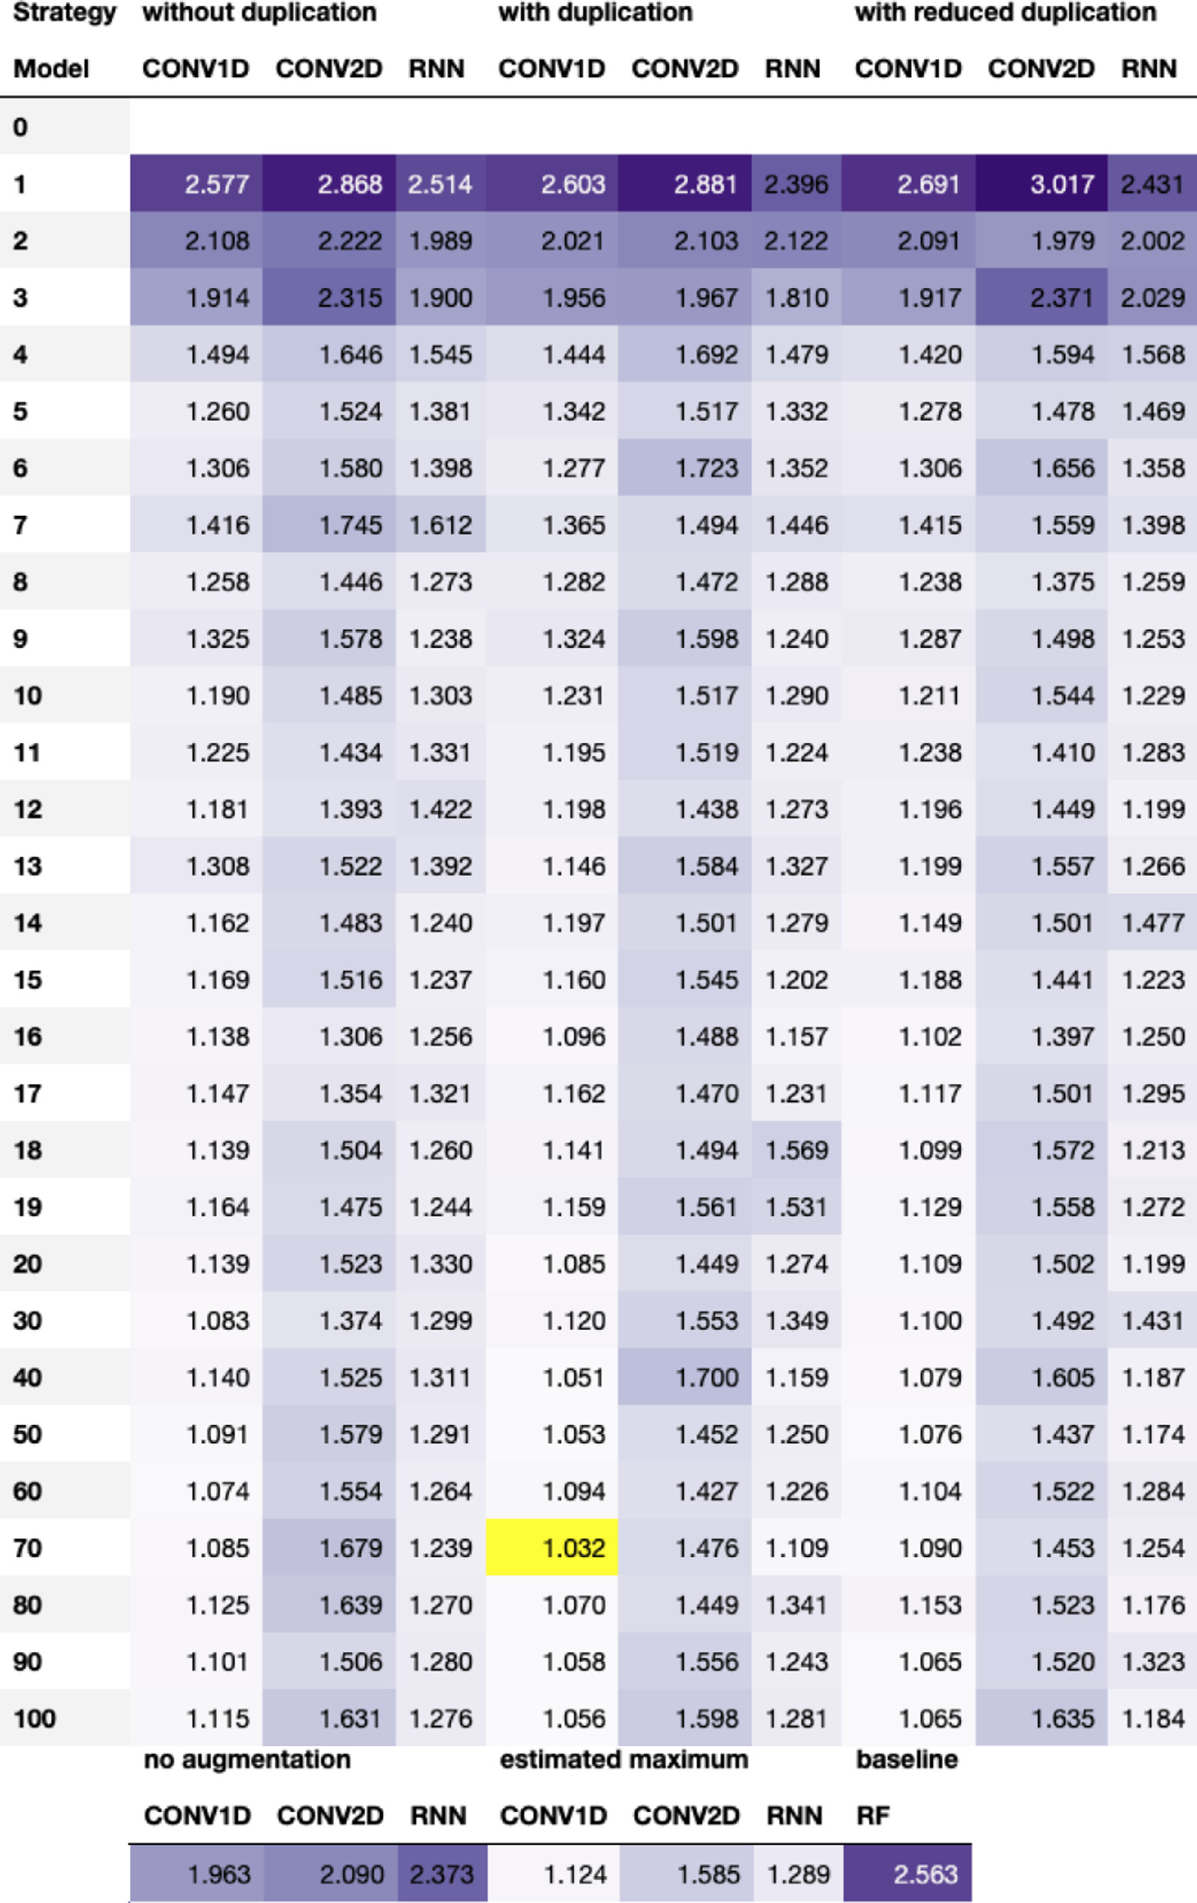

**tationontheFreeSolvdataset.**Thetable   
showstherootmeansquarederror(RMSE)   
onthetestsetforthreedeeplearningmod-  
elsandfiveSMILESaugmentationstrate-  
gies,usingvariousaugmentationnumbers,   
aswellasabaselineconsistingofaRan-  
domForest(RF)modelwithMorganfin-  
gerprintasinput.Thelighterthepurple   
color,thebetterthemodel.Theoverallbest   
settingishighlightedinyellow,whichfor   
theFreeSolvdatasetisaugmentingthe   
dataset70timeskeepingallduplicates   
andtraininga1Dconvolutionalneuralnet-  
work(CONV1D).Forinterpretationofthe   
referencestocolorinthisfigurelegend,the   
readerisreferredtothewebversionofthis   
article.

11

*T.B.Kimber,M.GagnebinandA.Volkamer*  *ArtificialIntelligenceintheLifeSciences1(2021)100014*

**Fig.A2.TestRMSEusingdataaugmen-**

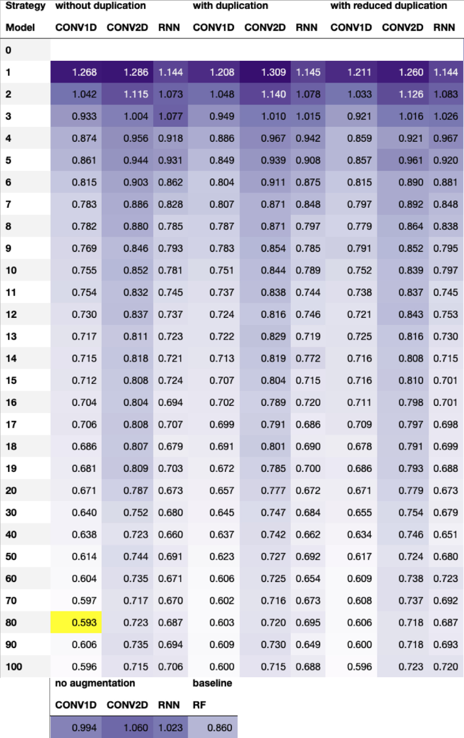

**tationonthelipophilicitydataset.**The   
tableshowstherootmeansquareder-  
ror(RMSE)onthetestsetforthreedeep   
learningmodelsandfiveSMILESaugmen-  
tationstrategies,usingvariousaugmenta-  
tionnumbers,aswellasabaselineconsist-  
ingofaRandomForest(RF)modelwith   
Morganfingerprintasinput.Thelighter   
thepurplecolor,thebetterthemodel.The   
overallbestsettingishighlightedinyel-  
low,whichforthelipophilicitydatasetis   
augmentingthedataset80timesremoving   
duplicatesandtraininga1Dconvolutional   
neuralnetwork(CONV1D).Forinterpreta-  
tionofthereferencestocolorinthisfig-  
urelegend,thereaderisreferredtotheweb   
versionofthisarticle.

12

*T.B.Kimber,M.GagnebinandA.Volkamer*

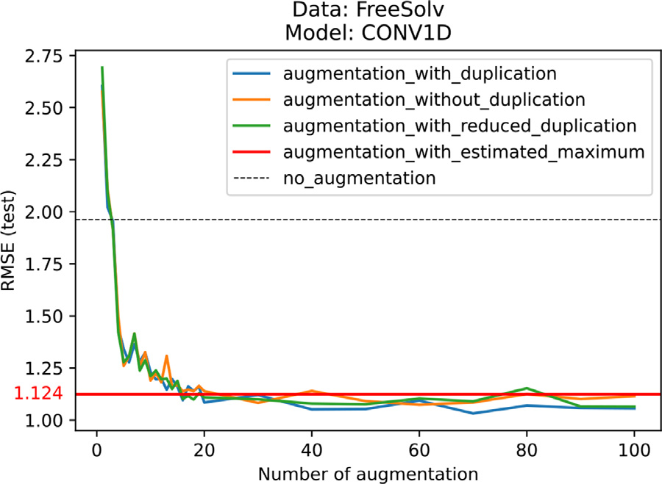

**Fig.A3.GeneratingalargeportionoftheSMILESspacedoesnotlead tothebestperformance.**EventhoughtheCONV1Dmodelispresentedwith SMILESvariationsthatcoveralargeportionoftheSMILESspaceusingtheaug-mentationsstrategywithestimatedmaximum,ontheFreeSolvdataset,this strategydoesnotachievethebestresults.

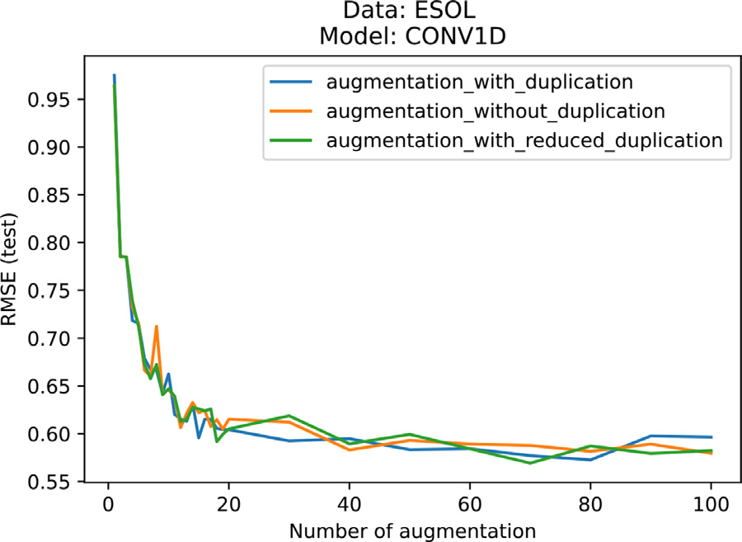

**Fig.A4.Performancereachesaplateauindependentlyoftheaugmenta-tionstrategy.**TheperformanceoftheCONV1Dmodeltrainedandevaluated ontheESOLdatasetreachesatestRMSEvalueslightlybelow0.6asof40aug-mentationstepsandfluctuatesbelowthisvaluethereafter,forallaugmentation strategies:with,without,andwithreducedduplication.

*ArtificialIntelligenceintheLifeSciences1(2021)100014*

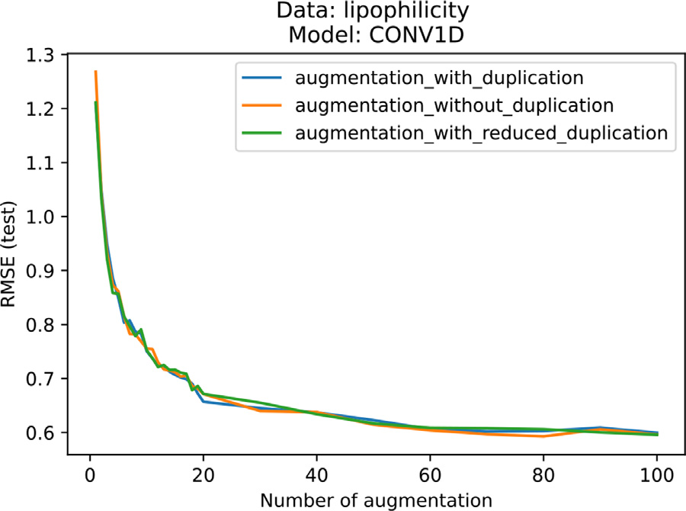

**Fig.A5.Performancereachesaplateauindependentlyoftheaugmenta-tionstrategy.**TheperformanceoftheCONV1Dmodeltrainedandevaluated onthelipophilicitydatasetreachesatestRMSEvalueslightlybelow0.6asof 60augmentationstepsandfluctuatesbelowthisvaluethereafter,forallaug-mentationstrategies:with,without,andwithreducedduplication.

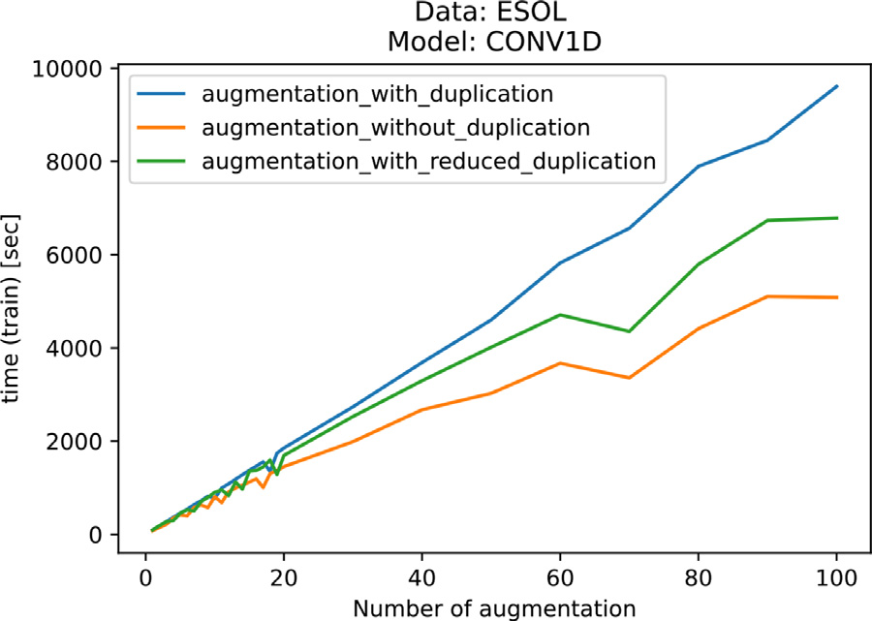

**Fig.A6.Trade-off betweenperformanceandcomputationtime.**Asex-pected,thetrainingtimeoftheCONV1DmodelontheESOLdataincreases withtheaugmentationnumberforallaugmentationstrategies:with,without, andwithreducedduplication.Augmentingthetrainingsetby100andkeeping duplicateleadsto90200datapoints(seeTable1).TrainingthemodelonaGPU takesapproximatelythreehoursandreachesatestRMSEof0.580(seeFigure2). However,augmentingthedatabyjust19leadstoatestRMSEof0.605inless than30minutes.

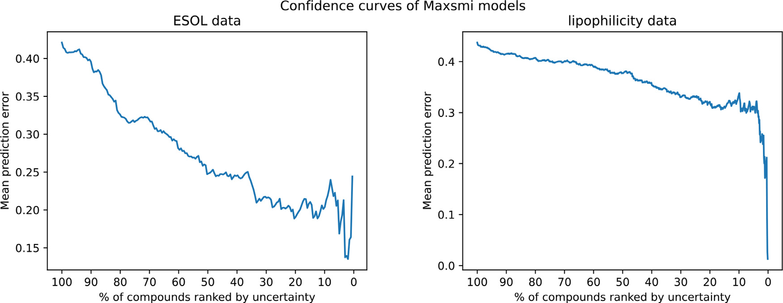

**Fig.A7.ConfidencecurvesoftheMaxsmimodelsontheESOLandlipophilicitydata.**Thegeneraltrendofthecurveintheleftplot(theESOLdata)isdecreasing, showingarelationshipbetweenhighconfidenceandsmallmeanpredictionerror.Althoughalsogenerallydecreasing,themeanpredictionerrorintherightplot (thelipophilicitydata)isstillabove0.3whenonlykeepingthe10%ofcompoundswiththehighestconfidence.

13

*T.B.Kimber,M.GagnebinandA.Volkamer*

**References**

[1]PaulSM,MytelkaDS,DunwiddieCT,PersingerCC,MunosBH,LindborgSR,etal.

Howtoimprover&dproductivity:thepharma[ceuticalindustry’s](https://doi.org/10.1038/nrd3078)grandchallenge. NatRevDrugDiscovery2010;9(3):203–14.doi[:10.1038/nrd3078.](https://doi.org/10.1038/nrd3078)

[2]ScannellJW,BlanckleyA,BoldonH,Warr[ingtonB.Diagno](https://doi.org/10.1038/nrd3078)singthedecline in[pharmaceuticalr&](https://doi.org/10.1038/nrd3681)defficiency.NatRevDrugDiscovery2012;11(3):191–200. doi[:10.1038/nrd3681.](https://doi.org/10.1038/nrd3681)

[3]Wa[ringMJ,Arrowsmi](https://doi.org/10.1038/nrd3681)thJ,LeachAR,LeesonPD,MandrellS,OwenRM,etal.An analysisoftheattritionofdrugcandidatesfromfour[majorpharmaceuti](https://doi.org/10.1038/nrd4609)calcompa-nies.NatRevDrugDiscovery2015;14(7):475–86.doi[:10.1038/nrd4609.](https://doi.org/10.1038/nrd4609)

[4]KrizhevskyA,SutskeverI,HintonGE.Imagenetclass[ificatio](https://doi.org/10.1038/nrd4609)n[withdee](https://doi.org/10.1038/nrd4609)[pconvol](https://doi.org/10.1145/3065386)u- tionalneuralnetworks.CommunACM2017;60(6):84–90.doi[:10.1145/3065386.](https://doi.org/10.1145/3065386) [5]GravesA,MohamedA-r,HintonG.Speechrecognitionwith[deeprecurrentneu](https://doi.org/10.1145/3065386)ral networks.In:2013IEEEInternat[ionalConferenceonAcoustics,S](https://doi.org/10.1109/ICASSP.2013.6638947)peechandSignal Processing;2013.p.6645–9.doi[:10.1109/ICASSP.2013.6638947.](https://doi.org/10.1109/ICASSP.2013.6638947)

[6]JumperJ,EvansR,PritzelA,[GreenT,FigurnovM,Ronne](https://doi.org/10.1109/ICASSP.2013.6638947)bergerO,etal.

Highl[yaccurateproteinstructurepre](https://doi.org/10.1038/s41586-021-03819-2)dictionwithalphafold.Nature2021;596:583–9.doi[:10.1038/s41586-021-03819-2.](https://doi.org/10.1038/s41586-021-03819-2)

[[7]Feinb](https://doi.org/10.1021/acscentsci.8b00507)[ergEN,SurD,WuZ,HusicB](https://doi.org/10.1038/s41586-021-03819-2)[E,MaiH,LiY,etal.Potentialnetformolec-ularpropertyprediction.ACSCentSci2018;4(11):1520–30.doi:10.1021/acs-centsci.8b00507.](https://doi.org/10.1021/acscentsci.8b00507)

[[8]SattarovB,BaskinII,HorvathD,MarcouG,BjerrumEJ,VarnekA.Denovo](https://doi.org/10.1021/acscentsci.8b00507) moleculardesignbycombiningdeepautoencoderrecurrentneuralnetworks wit[hgenerativetopographic](https://doi.org/10.1021/acs.jcim.8b00751)mapping.JChemInfModel2019;59(3):1182–96. doi[:10.1021/acs.jcim.8b00751.](https://doi.org/10.1021/acs.jcim.8b00751)

[9]We[belHE,KimberTB,Radetzk](https://doi.org/10.1021/acs.jcim.8b00751)iS,NeuenschwanderM,Nazaré M,VolkamerA.Re-vealingcytotoxicsubstructuresi[nmoleculesusingdeeplearnin](https://doi.org/10.1007/s10822-020-00310-4)g.JComputAided MolDes2020;34(7):731–46.doi[:10.1007/s10822-020-00310-4.](https://doi.org/10.1007/s10822-020-00310-4)

[10][GoodfellowI,BengioY,Cour](http://www.deeplearningbook.org)[villeA.Deeplearning.](https://doi.org/10.1007/s10822-020-00310-4)MITPress;2016.

[http://www.deeplearningbook.org](http://refhub.elsevier.com/S2667-3185(21)00014-3/sbref0011)   
[[11]BisongE.GoogleColaboratory.Berkeley,CA:Apress;2019.p.59–64.ISBN](http://refhub.elsevier.com/S2667-3185(21)00014-3/sbref0011)  [978-1-4842-4470-8](http://refhub.elsevier.com/S2667-3185(21)00014-3/sbref0011)   
[[12]Kaggle.https://www.kaggle.com/;2021.[Online;accessed27-August-2021].](http://refhub.elsevier.com/S2667-3185(21)00014-3/sbref0011) [13]ParksC[D,GaiebZ,ChiuM,Ya](https://www.kaggle.com/)ngH,ShaoC,WaltersWP,etal.D3RGrand challenge4:blindpredictionofprotein–ligandposes,affinityrankings,and rela[tivebindingfreeenergies.J](https://doi.org/10.1007/s10822-020-00289-y)ComputAidedMolDes2020;34(2):99–119. doi[:10.1007/s10822-020-00289-y.](https://doi.org/10.1007/s10822-020-00289-y)

[14]Hu[angR,XiaM.Editorial:Tox21](https://doi.org/10.1007/s10822-020-00289-y)challengetobuildpredictivemodelsofnuclear receptorandstressresponsepathwaysasmediated[byexposuretoenvironmen](https://doi.org/10.3389/fenvs.2017.00003)tal toxicantsanddrugs.FrontEnvironSci2017;5:3.doi[:10.3389/fenvs.2017.00003.](https://doi.org/10.3389/fenvs.2017.00003) [15]WeiningerD.Smiles,achemicallanguageandinf[ormationsystem.1.introd](https://doi.org/10.3389/fenvs.2017.00003)uc- tion[tomethodologyande](https://doi.org/10.1021/ci00057a005)ncodingrules.JChemInfComputSci1988;28(1):31–6. doi[:10.1021/ci00057a005.](https://doi.org/10.1021/ci00057a005)

[16]O’B[oyleNM.Towardsa](https://doi.org/10.1021/ci00057a005)universalSMILESrepresentation-astandardmethod to[generatecanonicalSMIL](https://doi.org/10.1186/1758-2946-4-22)ESbasedontheinchi.JCheminform2012;4(1). doi[:10.1186/1758-2946-4-22.](https://doi.org/10.1186/1758-2946-4-22)

[17]We[iningerD,WeiningerA,](https://doi.org/10.1186/1758-2946-4-22)WeiningerJL.Smiles.2.algorithmforgenera-tion[ofuniquesmilesn](https://doi.org/10.1021/ci00062a008)otation.JChemInfComputSci1989;29(2):97–101. doi[:10.1021/ci00062a008.](https://doi.org/10.1021/ci00062a008)

[18]He[mmerichJ,Asilar](https://doi.org/10.1021/ci00062a008)E,EckerGF.COVER:Conformationaloversam-plin[gasdataaugmentation](https://doi.org/10.1186/s13321-020-00420-z)formolecules.JCheminform2020;12(1). doi[:10.1186/s13321-020-00420-z.](https://doi.org/10.1186/s13321-020-00420-z)

[19]Li[Y,RezaeiMA,LiC,LiX.Dee](https://doi.org/10.1186/s13321-020-00420-z)patom:Aframeworkforprotein-ligandbinding affinityprediction.In:2019IEEEInternat[ionalConferenceonBioinformatics](https://doi.org/10.1109/BIBM47256.2019.8982964)and Biomedicine(BIBM);2019.p.303–10.doi[:10.1109/BIBM47256.2019.8982964.](https://doi.org/10.1109/BIBM47256.2019.8982964)

[20]BjerrumEJ.Smilesenumerationas[dataaugmentationforneural](https://doi.org/10.1109/BIBM47256.2019.8982964)net-[workmodelingofmolecules](https://arxiv.org/abs/1703.07076).arXivpreprintarXiv:1703070762017.

<https://arxiv.org/abs/1703.07076>  
[21][LiX,FourchesD.Inductivet](https://arxiv.org/abs/1703.07076)ransferlearningformolecularactivitypre- dict[ion:next-genQSARmodels](https://doi.org/10.1186/s13321-020-00430-x)withmolpmofit.JCheminform2020;12(1). doi[:10.1186/s13321-020-00430-x.](https://doi.org/10.1186/s13321-020-00430-x)

[22]Kim[berTB,EngelkeS,Tetko](https://doi.org/10.1186/s13321-020-00430-x)IV,BrunoE,GodinG.Synergyeffectbe-tweenconvolutionalneuralnetworksandthemultiplicityofsmilesforim-[provementofmolecularpredic](https://arxiv.org/abs/1812.04439)tion.arXivpreprintarXiv:1812044392018.

<https://arxiv.org/abs/1812.04439>  
[23][TetkoIV,KarpovP,BrunoE,Kimb](https://arxiv.org/abs/1812.04439)erTB,GodinG.Augmentationiswhatyouneed!.

In:TetkoIV,Kůrková V,KarpovP,TheisF,editors.ArtificialNeuralNetworksand MachineLearning– ICANN2019:Workshop[andSpecialSessions.Cham:Sp](https://doi.org/10.1007/978-3-030-30493-5_79)ringer InternationalPublishing;2019.p.831–5.doi[:10.1007/978-3-030-30493-5_79.](https://doi.org/10.1007/978-3-030-30493-5_79)ISBN 978-3-030-30493-5   
[24]ShortenC,KhoshgoftaarTM.[Asurveyonimagedataaugm](https://doi.org/10.1186/s40537-019-0197-0)entationfordeeplearn- ing.JBigData2019;6(1).doi[:10.1186/s40537-019-0197-0.](https://doi.org/10.1186/s40537-019-0197-0)

[25]TetkoIV,KarpovP,Deursen[RV,GodinG.State-of-the-art](https://doi.org/10.1186/s40537-019-0197-0)augmentedNLPtrans-for[mermodelsfordirectandsing](https://doi.org/10.1038/s41467-020-19266-y)le-stepretrosynthesis.NatCommun2020;11(1). doi[:10.1038/s41467-020-19266-y.](https://doi.org/10.1038/s41467-020-19266-y)

[26]Sum[nerD,HeJ,ThakkarA,Eng](https://doi.org/10.1038/s41467-020-19266-y)kvistO,BjerrumEJ.Levenshteinaugmentation improves[performanceofsmilesbaseddeep-l](https://doi.org/10.26434/chemrxiv.12562121.v2)earningsynthesisprediction.ChemRxiv 2020.doi[:10.26434/chemrxiv.12562121.v2.](https://doi.org/10.26434/chemrxiv.12562121.v2)

[27]Arús-Pous[J,JohanssonSV,PrykhodkoO,Bje](https://doi.org/10.26434/chemrxiv.12562121.v2)rrumEJ,TyrchanC,ReymondJ-L,etal.

RandomizedSMILESstringsi[mprovethequalityofmolecu](https://doi.org/10.1186/s13321-019-0393-0)largenerativemodels.J Cheminform2019;11(1).doi[:10.1186/s13321-019-0393-0.](https://doi.org/10.1186/s13321-019-0393-0)

[28]vanDeursenR,ErtlP,Tetko[IV,GodinG.GEN:Highlye](https://doi.org/10.1186/s13321-019-0393-0)fficientSMILESexplorer usi[ngautodidacticgenerativeexa](https://doi.org/10.1186/s13321-020-00425-8)minationnetworks.JCheminform2020;12(1). doi[:10.1186/s13321-020-00425-8.](https://doi.org/10.1186/s13321-020-00425-8)

[29]RD[Kit:Open-sourcecheminforma](https://doi.org/10.1186/s13321-020-00425-8)tics.<http://www.rdkit.org>[Online;accessed01- July-2021];2021.

*ArtificialIntelligenceintheLifeSciences1(2021)100014*

[30][KazilJ,JarmulK.Datawranglingwithpython:tipsandtoolstomakeyourlife](http://refhub.elsevier.com/S2667-3185(21)00014-3/sbref0030)  [easier.1st.O’ReillyMedia,Inc.;2016.ISBN1491948817](http://refhub.elsevier.com/S2667-3185(21)00014-3/sbref0030)   
[31][TagasovskaN,Lopez-PazD.Single-modeluncertaintiesfordeeplearning.arXiv](http://refhub.elsevier.com/S2667-3185(21)00014-3/sbref0030)  preprintarXiv:1811009082019.<https://arxiv.org/abs/1811.00908>  
[32]ScaliaG,GrambowCA,PerniciB,[LiY-P,GreenWH.Evaluatingscala](https://arxiv.org/abs/1811.00908)bleuncertainty estimationmethodsfordeeplearning[-basedmolecularproperty](https://doi.org/10.1021/acs.jcim.9b00975)prediction.JChem InfModel2020;60(6):2697–717.doi[:10.1021/acs.jcim.9b00975.](https://doi.org/10.1021/acs.jcim.9b00975)

[33]AyhanM.S.,BerensP.Test-tim[edataaugmentationf](https://doi.org/10.1021/acs.jcim.9b00975)orestimationof [heteroscedasticaleatoricuncertainty](https://openreview.net/pdf?id=rJZz-knjz)indeepneuralnetworks.2018. [https://openreview.net/pdf?id=rJZz-knjz.](https://openreview.net/pdf?id=rJZz-knjz)

[34][WuZ,RamsundarB,FeinbergEN,Gom](https://openreview.net/pdf?id=rJZz-knjz)esJ,GeniesseC,PappuAS,LeswingK, PandeV.Molecule[net:abenchmarkfor](https://doi.org/10.1039/C7SC02664A)molecularmachinelearning.ChemSci 2018;9:513–30.doi[:10.1039/C7SC02664A.](https://doi.org/10.1039/C7SC02664A)

[35]GaultonA,Hersey[A,NowotkaM,Bent](https://doi.org/10.1039/C7SC02664A)oAP,ChambersJ,MendezD,etal.

The[ChEMBLdatabasei](https://doi.org/10.1093/nar/gkw1074)n2017.NucleicAcidsRes2016;45(D1):D945–54. doi[:10.1093/nar/gkw1074.](https://doi.org/10.1093/nar/gkw1074)

[36]Ma[yrA,KlambauerG,U](https://doi.org/10.1093/nar/gkw1074)nterthinerT,SteijaertM,WegnerJK,CeulemansH, ClevertD-A,HochreiterS.Large-scalecomparisonofmachinelearning met[hodsfordrugtarget](https://doi.org/10.1039/C8SC00148K)predictiononChEMBL.ChemSci2018;9:5441–51. doi[:10.1039/C8SC00148K.](https://doi.org/10.1039/C8SC00148K)

[37]Zha[ngY,LeeAA.Bayesian](https://doi.org/10.1039/C8SC00148K)semi-supervisedlearningforuncertainty-calibratedpre-dict[ionofmolecularprop](https://doi.org/10.1039/C9SC00616H)ertiesandactivelearning.ChemSci2019;10:8154–63. [doi](http://refhub.elsevier.com/S2667-3185(21)00014-3/sbref0038)[:10.1039/C9SC00616H.](https://doi.org/10.1039/C9SC00616H)

[38][Ra](http://refhub.elsevier.com/S2667-3185(21)00014-3/sbref0038)[msundarB,EastmanP,](https://doi.org/10.1039/C9SC00616H)[WaltersP,PandeV,LeswingK,WuZ.Deeplearningfor](http://refhub.elsevier.com/S2667-3185(21)00014-3/sbref0038)  [thelifesciences.O’ReillyMedia;2019.ISBN9781492039839](http://refhub.elsevier.com/S2667-3185(21)00014-3/sbref0038)   
[39][DelaneyJS.Esol:estimatingaqueoussolubilitydirectlyfrommolecularstructure.J](http://refhub.elsevier.com/S2667-3185(21)00014-3/sbref0038)  ChemInfComputSci2004;44(3):1000–5.doi[:10.1021/ci034243x.](https://doi.org/10.1021/ci034243x)

[40]MobleyDL,GuthrieJP.FreeSolv:adatabaseo[fexperimentalandc](https://doi.org/10.1021/ci034243x)alculatedhydra-tion[freeenergies,withinputfi](https://doi.org/10.1007/s10822-014-9747-x)les.JComputAidedMolDes2014;28(7):711–20. doi[:10.1007/s10822-014-9747-x.](https://doi.org/10.1007/s10822-014-9747-x)

[41]ChE[MBL.https://www.ebi.ac.u](https://doi.org/10.1007/s10822-014-9747-x)[k/chembl/](https://www.ebi.ac.uk/chembl/)[Online;accessed27-August-2021]; 2021.

[42]KooistraAJ,VolkamerA.Kinase-centriccomputationaldrugdevelopment.

In:[AnnualReportsinMedici](https://doi.org/10.1016/bs.armc.2017.08.001)nalChemistry.Elsevier;2017.p.197–236. doi[:10.1016/bs.armc.2017.08.001.](https://doi.org/10.1016/bs.armc.2017.08.001)

[43]Ope[nKinome.http://openkinome.](https://doi.org/10.1016/bs.armc.2017.08.001)[org/](http://openkinome.org/)[Online;accessed27-August-2021];2021. [44]HerbstRS.R[eviewofepidermalgro](http://openkinome.org/)wthfactorreceptorbiology.International Jou[rnalofRadiationOncology](https://doi.org/10.1016/j.ijrobp.2003.11.041)∗Biology∗Physics2004;59(2,Supplement):S21–6. doi[:10.1016/j.ijrobp.2003.11.041.](https://doi.org/10.1016/j.ijrobp.2003.11.041)

[45]Con[sortiumTU.Uniprot:theuni](https://doi.org/10.1016/j.ijrobp.2003.11.041)ve[rsalproteinknowledge](https://doi.org/10.1093/nar/gkaa1100)basein2021.Nucleic AcidsRes2020;49(D1):D480–9.doi[:10.1093/nar/gkaa1100.](https://doi.org/10.1093/nar/gkaa1100)

[46]IC50Values.Offerman[nsS,RosenthalW,editors.Berlin,H](https://doi.org/10.1007/978-3-540-38918-7_5943)[eid](https://doi.org/10.1093/nar/gkaa1100)elberg:SpringerBerlin Heidelberg;2008.doi[:10.1007/978-3-540-38918-7_5943.](https://doi.org/10.1007/978-3-540-38918-7_5943)ISBN978-3-540-38918-7 [47]KimberTB,ChenY,V[olkamerA.Deeplearninginvirtual](https://doi.org/10.1007/978-3-540-38918-7_5943)[screening:recentapp](https://doi.org/10.3390/ijms22094435)lica-tionsanddevelopments.IntJMolSci2021;22(9).doi[:10.3390/ijms22094435.](https://doi.org/10.3390/ijms22094435)

[48]Me[ansquarederror.SammutC,Web](https://doi.org/10.1007/978-0-387-30164-8_528)bGI,editors.Bos[ton,MA:SpringerUS;2](https://doi.org/10.3390/ijms22094435)010.

doi[:10.1007/978-0-387-30164-8_528.](https://doi.org/10.1007/978-0-387-30164-8_528)ISBN978-0-387-30164-8   
[49]Kvå[lsethTO.Cautionarynote](https://doi.org/10.1007/978-0-387-30164-8_528)[ab](https://doi.org/10.1080/00031305.1985.10479448)out*𝑟*2.AmStat1985;39(4):279–85. doi[:10.1080/00031305.1985.10479448.](https://doi.org/10.1080/00031305.1985.10479448)

[50]Bre[iman](https://doi.org/10.1080/00031305.1985.10479448)  [L.](https://doi.org/10.1080/00031305.1985.10479448)  [Random](https://doi.org/10.1080/00031305.1985.10479448)  [forests.](https://doi.org/10.1080/00031305.1985.10479448)  Mach Learn 2001;45(1):5–32. doi[:10.1023/A:1010933404324.](https://doi.org/10.1023/A:1010933404324)

[51]Ped[regosaF,VaroquauxG,Gr](https://doi.org/10.1023/A:1010933404324)amfortA,MichelV,ThirionB,GriselO,Blon-delM,aPrettenhoferP,WeissR,DubourgV,VanderplasJ,PassosA, CournapeauD,BrucherM,PerrotM,DuchesnayE.Scikit-learn:machine [learninginpython.JournalofMachineLea](http://jmlr.org/papers/v12/pedregosa11a.html)rningResearch2011;12:2825–30.

<http://jmlr.org/papers/v12/pedregosa11a.html>  
[52][BennettL.,MelchersB.,ProppeB.Curta:A](http://jmlr.org/papers/v12/pedregosa11a.html)[general-purposehigh-performance](https://doi.org/10.17169/refubium-26754)  [computeratZedat,FreieUniversitätBerlin.2020.https://doi.org/10.17169/](https://doi.org/10.17169/refubium-26754)  [refubium-26754.](https://doi.org/10.17169/refubium-26754)

[53][VanRossumG,DrakeFL.Python3referencemanual.ScottsValley,CA:CreateSpace;](https://doi.org/10.17169/refubium-26754)  [2009.ISBN1441412697](http://refhub.elsevier.com/S2667-3185(21)00014-3/sbref0053)   
[54][vanRossumG,WarsawB,CoghlanN.StyleguideforPythoncode.PEP;2001.](http://refhub.elsevier.com/S2667-3185(21)00014-3/sbref0053)

<https://www.python.org/dev/peps/pep-0008/>  
[55][ReadtheDocs.https://readthedocs.io/en/stabl](https://www.python.org/dev/peps/pep-0008/)[e/](https://readthedocs.io/en/stable/)[Online;accessed30-July-2021]; 2021.

[56]Anacondasoftwaredistribution.2020.[https://anaconda.com/.](https://anaconda.com/)

[57]PaszkeA,GrossS,MassaF,LererA[,BradburyJ,Chanan](https://anaconda.com/)G,KilleenT,LinZ, GimelsheinN,AntigaL,DesmaisonA,KopfA,YangE,DeVitoZ,RaisonM,TejaniA, ChilamkurthyS,SteinerB,FangL,BaiJ,ChintalaS.Pytorch:animperativestyle, high-performancedeeplearninglibrary.In:WallachH,LarochelleH,BeygelzimerA, [d’Alché-BucF,FoxE,GarnettR,editors.AdvancesinNeuralInformationProcessing Systems32.CurranAssociates,Inc.;2019.p.8024–35.http://papers.neurips.cc/ paper/9015-pytorch-an-imperative-style-high-performance-deep-learning-library.](http://papers.neurips.cc/paper/9015-pytorch-an-imperative-style-high-performance-deep-learning-library.pdf)

[pdf](http://papers.neurips.cc/paper/9015-pytorch-an-imperative-style-high-performance-deep-learning-library.pdf)   
[58][HarrisCR,MillmanKJ,vanderWaltSJ,GommersR,VirtanenP,Courna-](http://papers.neurips.cc/paper/9015-pytorch-an-imperative-style-high-performance-deep-learning-library.pdf) pea[uD,etal.Arrayprogrammi](https://doi.org/10.1038/s41586-020-2649-2)ngwithnumpy.Nature2020;585(7825):357–62. doi[:10.1038/s41586-020-2649-2.](https://doi.org/10.1038/s41586-020-2649-2)

[59]The[pandasdevelopmentteam.](https://doi.org/10.1038/s41586-020-2649-2)pandas-dev/pandas:Pandas.2020.10.5281/zen- odo.3509134   
[60]GitHubActions.<https://docs.github.com/en/actions>[Online;accessed30-July- 2021];[2021.](https://docs.pytest.org/)

[61]Pytest.<https://docs.pytest.org/>[[Online;a](https://docs.codecov.com/docs)ccessed30-July-2021];2021.

[62]Codeco[v.https://docs.codecov.](https://docs.pytest.org/)[com/docs](https://docs.codecov.com/docs)[Online;accessed30-July-2021];2021. [63]CarlesF,[BourgS,MeyerC,BonnetP](https://docs.codecov.com/docs).PKIDB:acurated,annotatedandup- dat[eddatabaseofproteinkinase](https://doi.org/10.3390/molecules23040908)inhibitorsinclinicaltrials.Molecules2018;23(4). doi[:10.3390/molecules23040908.](https://doi.org/10.3390/molecules23040908)

14